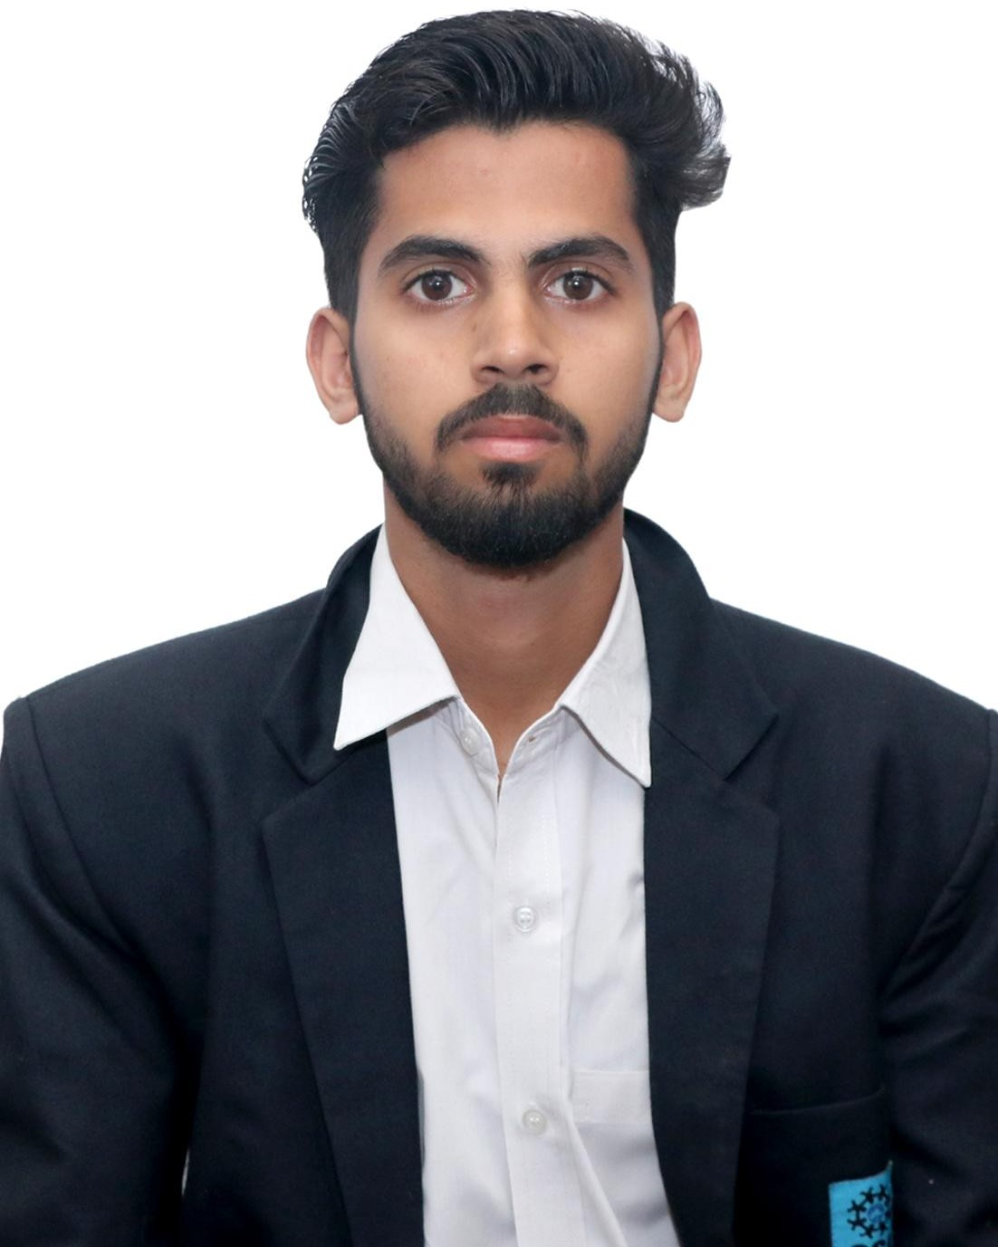

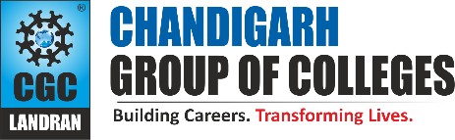Kartik Semwal

GHS-92,Sec-20,Panchkula,Haryana,134116 7973916799

8054179191

[Kartiksemwal50@gmail.com](mailto:Kartiksemwal50@gmail.com) [www.linkedin.com/in/kartik-semwal28/](http://www.linkedin.com/in/kartik-semwal28/)

# PROFESSIONAL SUMMARY

Passionate undergraduate in Computer Engineering with strong problem-solving and leadership abilities. Eager to innovate in the fusion of hardware and software systems, driven by curiosity and commitment. With sharp analytical skills, I thrive in challenging environments, contributing impactful solutions to Computer Science.

# TECHNICAL COMPETENCIES

**OS:** Windows | macOS

**Languages:** C | C++ | Python | HTML | CSS |JAVA

**Databases:** MySQL

**Other Interests:** Software Engineering, Operating System, Cloud Computing

# INTERPERSONAL SKILLS

Team Leadership|Cooperative-Nature|Empathy

|Problem-Solving

# INTERESTS & HOBBIES

Reading Books|Playing football|Singing

# LANGUAGES KNOWN

English | Hindi | Punjabi

# PERSONAL DETAILS

Mother’s Name:-Mrs.Nidhi

Father’s Name :- Mr.Jagmohan Prasad D.O.B:- 28-10-2002

# EDUCATION

Bachelors of Technology in Computer Science Engineering | Chandigarh Group of Colleges, Landran Session: 2020-2024 | Score: 7.54 CGPA

Intermediate (CBSE) | Government Model Sen. Sec. Public School Sec-8b, Chandigarh

Session: 2019-2020 | Percentage: 81.40%

Matriculation (CBSE) | Shishu Niketan Public School Sec-43,Chandigarh

Session: 2017-2018 | Percentage: 89.20%

# TRAINING & PROJECTS

**Python Game Project**

Dragon run game .It is entertainment based project in which i studied about the pygame library.Through this project i learnt about building frames ,key event ,etc features of the pygame.

**Android Training** Duration: 24 days Environment: Windows Languages/Database: Java **Health Care Project**

It is basic project for a health care in which many services are given like buy medicine ,health articles , find doctor etc. it does not give us manual working rather act as a clone model.

# ACADEMIC ACHIEVEMENTS

* Presented my working model of chromatography in National science day competion and secured 15 position out of 100.

# CERTIFICATIONS

* Android Basics and Hands-on by google development student club.
* AWS Academy cloud architecting

# EXTRA CURRICULAR & CO-CURRICULAR ACHIEVEMENTS

* Gained 2nd Position in football interdepartment competition.
* Worked as a coordinator in Technical event